**EVENING CME HELD ON 4TH AUGUST, 2019 AT SERAMPORE IMA BHAVAN**

On 4th August 2019 at the premises of Serampore IMA Bhavan, a CME on Appropriate Antibiotics prescribing for the Medical Practitioners  and the Consultants organized by IMA Serampore Branch under the auspices of IMA  Headquarters in collaboration with GSK pharmaceutical Pvt. Ltd. The programme was inaugurated by the President of the branch, Dr. Pradip Kumar Das. In his inaugural speech, he narrated in 1934 with the advent of Penicillin by Alexander Flemming and its application in medical field in 1940, created an amazing effect in the field of infections particularly in case of soldiers who were badly affected in World War I. But since its inception in the application of Penicillin as antibiotics to control the infections, Alexander apprehended in the year 1945 that irrational use of antibiotics can create resistance to antibiotics and his apprehension was true in the year 1945 since then till today many antibiotics developed resistance. Now most of the common antibiotics developed resistance and caused a great threat in the medical arena. He concludes in his speech that organizing such type of CME is very pertinent in this respect. After his speech the Guest Speaker, Dr. Sandeep Lahiri, Professor of Pharmacology of SSKM Hospital, Kolkata spoke on details in lucid language the incidence, cause and consequences of antibiotic resistance to the community. He stressed that irrational use of antibiotics particularly in case of sore throat, running nose, conjunctiva congestion resulting from viral infections, use of antibiotics yield no fruitful results but can cause resistance to that particular antibiotics. Similarly doctors prescribe antibiotics in allergetic dermatitis and eczematous conditions of the skin yield antibiotic resistances. We have no stronger antibiotics in our hand now-a-days, so antibiotic resistance can cause more expenses of treatment, more staying in hospital and complicated illness. He also stressed prescribing antibiotics in proper doses in appropriate cases for proper periods, antibiotics should not be prescribed by quacks or taken from the medicine counters without prescribing by registered medical practitioners or taken from the medicines shops by showing the old or back dated prescriptions. He also enforced the periodical audit of prescriptions written by the medical practitioners on behalf of government sectors and his concern to the progressive antibiotic resistance by the adrandum use of antibiotics reflected in the discussion among the doctor members of IMA Serampore branch. He concluded that the whole medical fraternity will come forward for their sincere and whole-hearted co-operation for rational and appropriate prescribing antibiotics in future and he expected that co-operation and assistance from pharmaceutical industry for incurring their budget expenses into the research projects for getting newer generation of antibiotics. After his nice discussion lot of queries raised by the doctor members and it was readily answered by him. Vote of thanks were conveyed by the Secretary, Dr. Abhijnan Ghosh.

After the first session, second session was inaugurated by the Manager of ICICI, Bhadreswar branch, Smt. Poulami Basu Pal. She in her short speech spoke on Investor Educational programme and with the busy hectic schedule run by the doctor community how they invest their hard earn money for a good return without any hurdle. She introduced Mr. Sujoy kumar Saha, the eminent Resource Person of ICICI prudential who delivered in a very lucid language the various steps for easy going investment to be done by the doctors in their hectic busy professional lives without any obstacle. Most of the doctor members were impressed with his oral version and requested them to come another day for taking sessions on those particular subjects. As the first session was long and time consuming so they required fresh meeting with one to one discussion on the said topics. The session was ended with expressing thanks to the speakers.

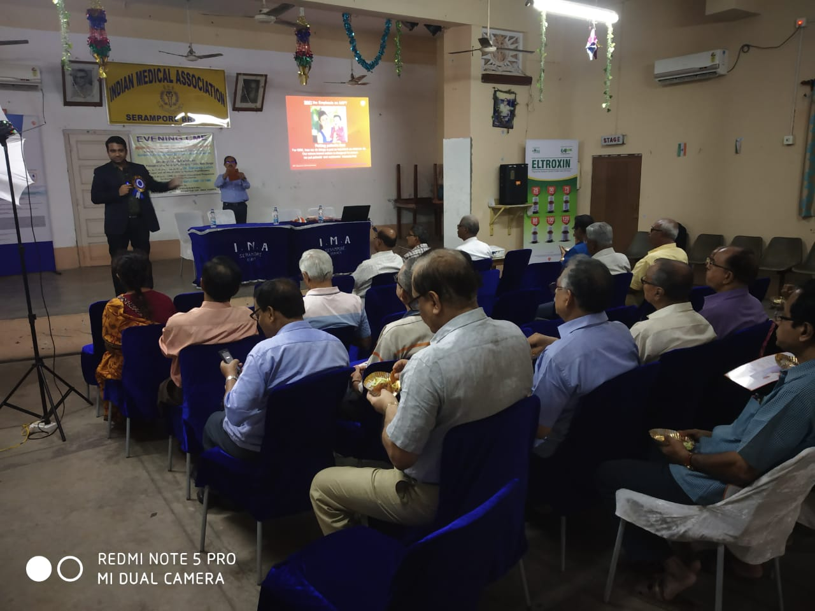

DR. SANDEEP LAHIRI SPOKE ON CME

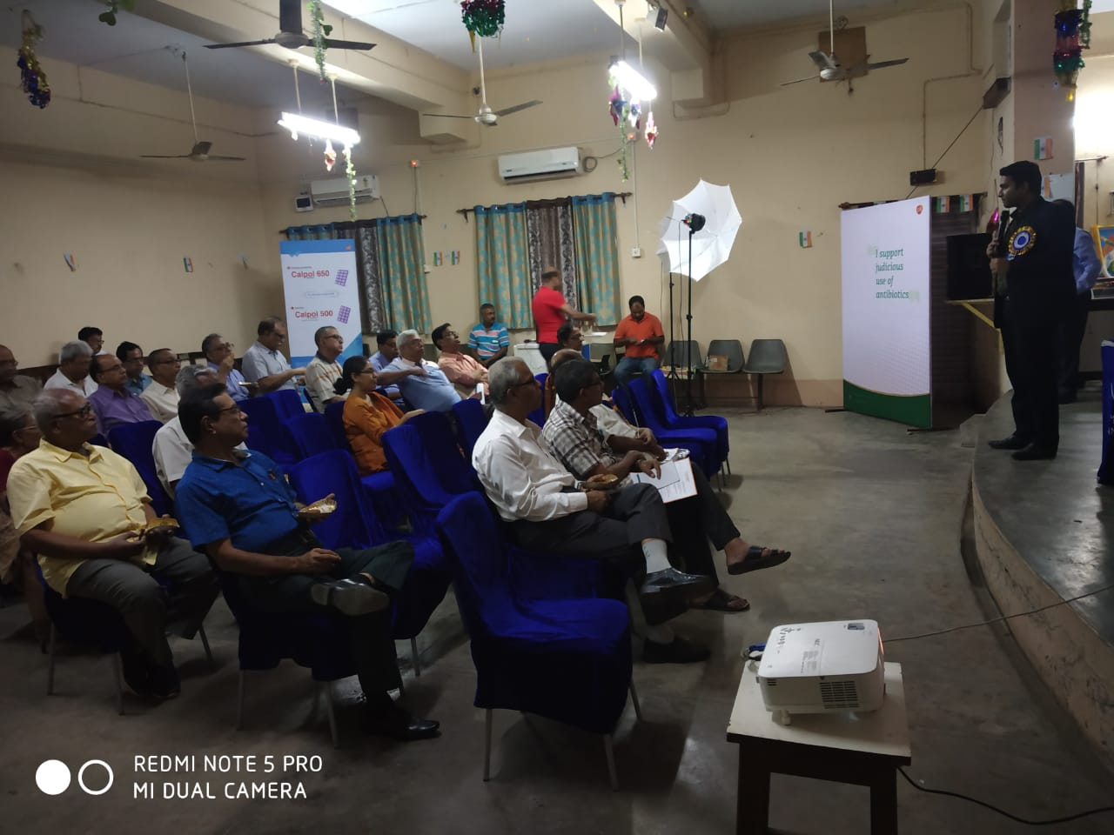

CME ON APPROPRIATE ANTIBIOTICS PRESCRIBING

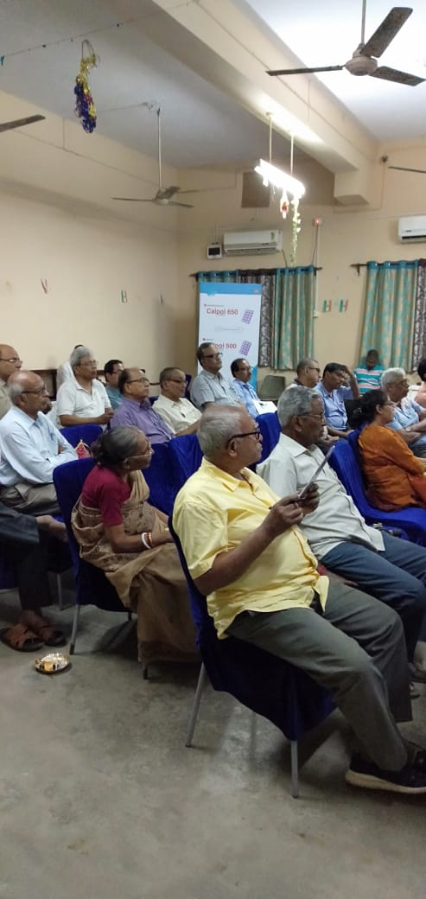

DOCTOR MEMBERS OF IMA SERAMPORE

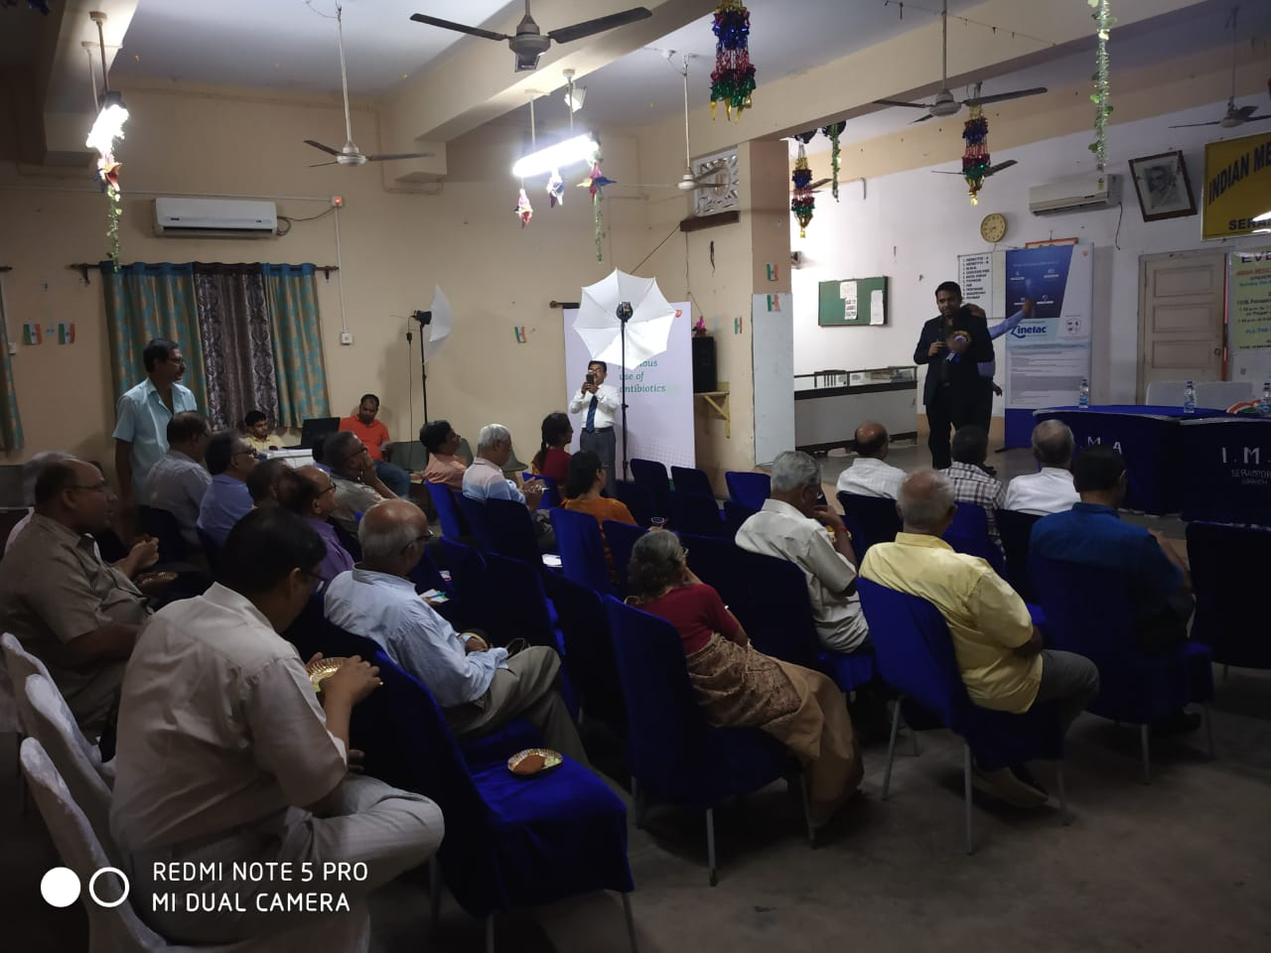

EVENING CME ON APPROPRIATE ANTIBIOTIC PRESCRIBING



PARTICIPANTS OF CME HELD ON 4TH AUGUST 2019

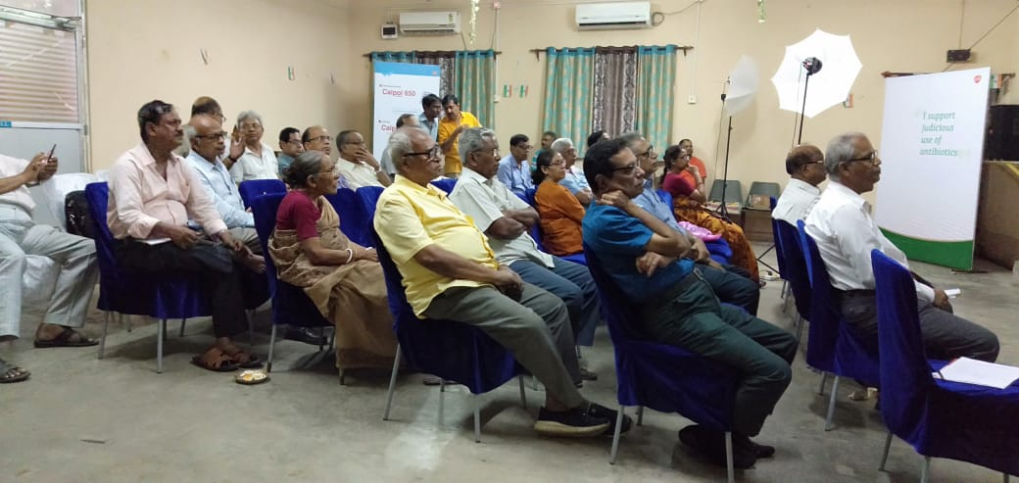

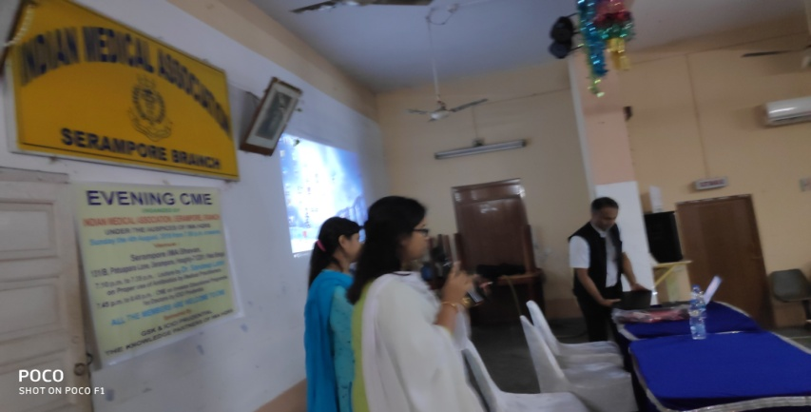

CME ON INVESTOR EDUCATIONAL OROGRAMME

DELIVERED BY BRANCH MANAGER OF ICICI

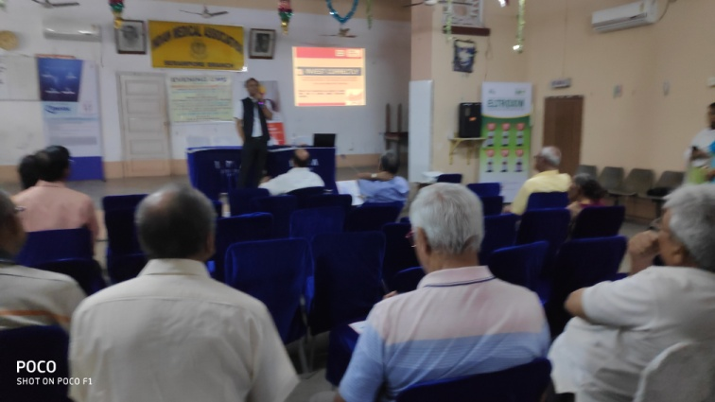

**MR. SUJOY SAHA SPOKE ON INVESTOR EDUCATIONAL**

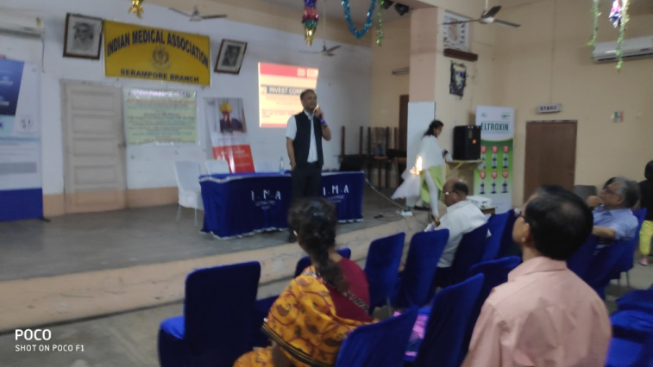

**MR. SUJOY SAHA SPOKE ON INVESTOR EDUCATIONAL**

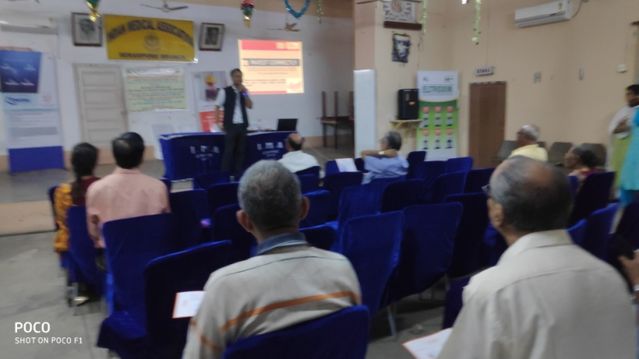

**MR. SUJOY SAHA SPOKE ON INVESTOR EDUCATIONAL**